The Stern-Brocot Tree

A Binary Fraction Tree
The mediant of two fractions a/b and c/d is the fraction (a+c)/(b+d) found by independently summing the numerators and denominators, a process jokingly called freshman fraction addition. Beginning with the ordered set 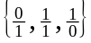, we can enlarge the set in stages by inserting the mediant of each pair of consecutive fractions between the pair. The first several stages are shown below, where for example, the mediant ½ is inserted between 0/1 and 1/1 in the 2nd row.

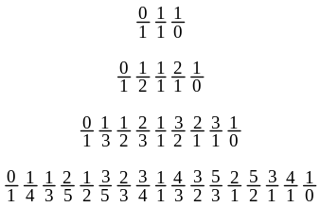

After the first generation, each new fraction is either to the left or to the right of a fraction generated in the previous stage, allowing us to arrange the fractions as a binary tree.
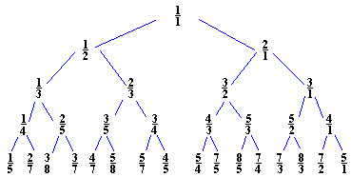

The resulting infinite tree, known as the Stern-Brocot tree because it was discovered independently by a mathematician named Stern (1858) and a clock-maker named Brocot (1860), has the remarkable property that every positive fraction expressed in lowest terms appears exactly once. Because of this we can associate with every positive fraction a binary string of L's and R's based on the Left and Right descents in the path from the root of the tree to the fraction. For example, 2/3 is reached by an LR-path, a branch to the Left followed by a branch to the Right.

We wish to write a program to converting between fractions and these LR-strings.

Exploration Preparations
- What LR-string corresponds to 7/4?
- What fraction corresponds to LRRLR?
- Suppose we have two fractions a/b and c/d, not necessarily reduced, stored as four integers. How can we compare them for equality without using floating point numbers?
- Inductively show that if a/b is the parent of c/d, then |ad-bc| = 1. Hint: |ad-bc| = |a(b+f)-b(a+e)| = |af-be|.
Exploration Outline
- How should we represent fractions?
- With a binary search strategy, how should we initialize low and hi?
- Convert fractions to strings using binary search.
- What if our fraction is not reduced?
- Convert strings to fractions using binary search.

Post-Exploration Exercises
- What string is returned for the fraction 1/1? Why does this make sense?
- What is the relationship between two fractions whose LR-encodings are the same length but different in every character?
- Define a Fraction class with overloaded output operator and modify our program to use it. In particular, the string-to-fraction function should return a Fraction object.

Discrete Binary Search
A sequential search through a list of N data items might take N comparisons. With sorted data, a binary search can cut the search time dramatically. The idea is to repeatedly cut the search range in half. Initially, the search target might be anywhere between the low and hi element of the list. By comparing the target with the middle item of the list, we can change either the low or hi element to obtain a new search range, on which we repeat the procedure until we find the target or the search range has one element. The general binary search algorithm to find target in a sorted vector v is as follows.

while(low <= hi)
mid = (low + hi) / 2;
if(target < v[mid])
hi = mid – 1;
else if(target > v[mid])
low = mid + 1;
else
return true; //target found!
//target is not in v

The key to a binary search's incredible efficiency is how quickly cutting a range in half can reduce the range to a single element. A search through a million elements involves no more than roughly 20 iterations, as compared to the possible million comparisons of sequentially searching. As a rule of thumb, expect roughly 3.3 iterations per number of digits in the vector's size. Even a search on a vector whose size is the largest 32-bit unsigned integer, over 4 billion, takes roughly 32 iterations.

Including the algorithm library gives you the function binary_search(), which returns true if it finds t in a sorted vector v with the following expression.

binary_search(v.begin(), v.end(), t)

